**Personal Notes**

Evaluation Kit/Module **(EVM)** (Integrated camera? -> Interactive Display, Position Tracking)

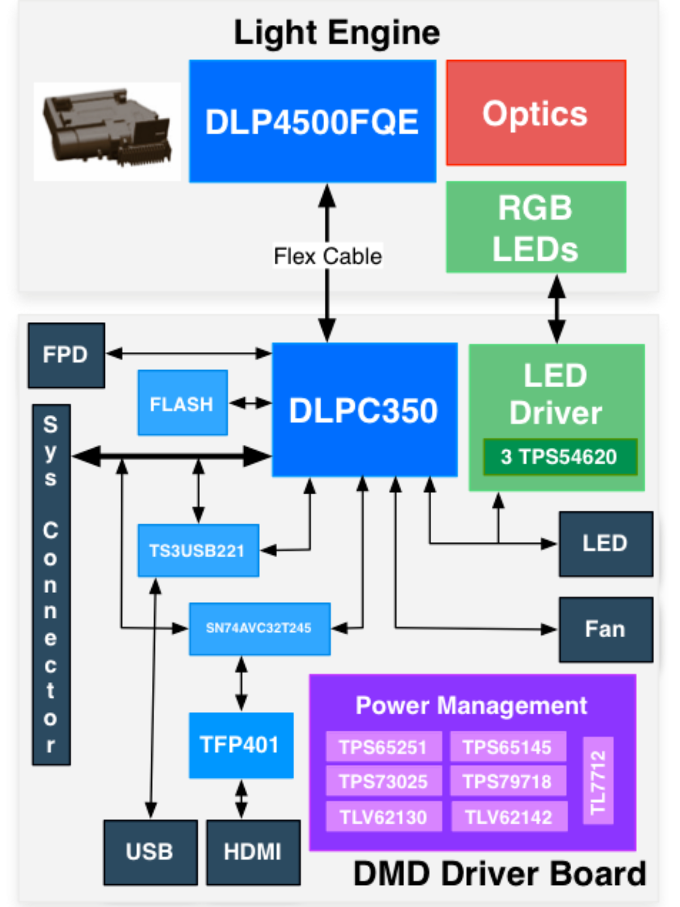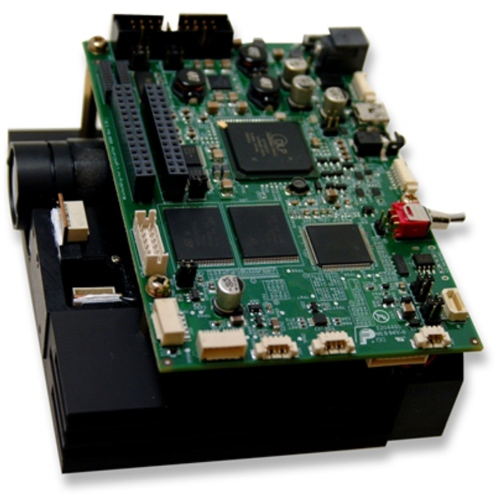

DLP LC EVM

* Light Engine
  + RGB LEDs
  + **912x1140** diamond pixels
  + WXGA DMD
  + Heat Sink, Fan
* Driver Board
  + LED Driver
  + DMD Controller
  + Power management
  + DVI to RGB conversion

(TFP401, 32MB Flash mem)

0.45 WXGA chipset

* DLP4500 – 0.45 WXGA FQE, FQD DMD
  + - DLP4500 **digital micromirror device** (DMD)
    - FQE/FQD are the two package types
* DLPC350 – DLP4500 **controller**
* **Flash memory** w/ config and firmware

|  |  |  |  |  |
| --- | --- | --- | --- | --- |
| Parameter | Min | Typ | Max | Unit |
| Brightness |  | 150 |  | Lm |
| LED Power Consumtion |  | 15 |  | W |
| Full-on Full-off contrast |  | 1000:1 |  |  |
| Uniformity | 80 | 90 |  | % |
| F-number |  | 2.1 |  |  |
| Throw Ratio |  | 100 |  |  |
| Offset |  | 100 |  | % |
| Focus Range | 0.5 | 1 | 2 | M |
| Img. Diag | 42.4 | 83.3 | 165.1 | Cm |

Potential communication methods

* I2C
* DVI -> Mini HDMI
* Mini USB

To Consider:

Power Consumption

Air circulation if EVM is in the case

Warnings

Don’t look into the Laser (Risk Group 2)

EMV is ESD sensitive

<https://www.ti.com/licreg/docs/swlicexportcontrol.tsp?form_type=2&prod_no=qt-win-opensource-4.8.4-mingw.zip&ref_url=ref_url=http://software-dl.ti.com/analog/analog_public_sw/dlp/&form_id=92084>

<https://www.ti.com/licreg/docs/swlicexportcontrol.tsp?form_type=2&prod_no=qt-creator-windows-opensource-2.6.2.zip&ref_url=ref_url=http://software-dl.ti.com/analog/analog_public_sw/dlp/&form_id=92084>